RECRUITING ASSISTANT FOR HR MANAGER

# 1 INTRODUCTION

1.1 Overview

To make the existing app more efficient for the HR team we create custom objects and relationships to store and access the data more efficiently. We install an unmanaged package in the org to get metadata that acts as existing data in the recruitment app.

1.2 Purpose

We make the recruiting app more efficient by using unmanaged package

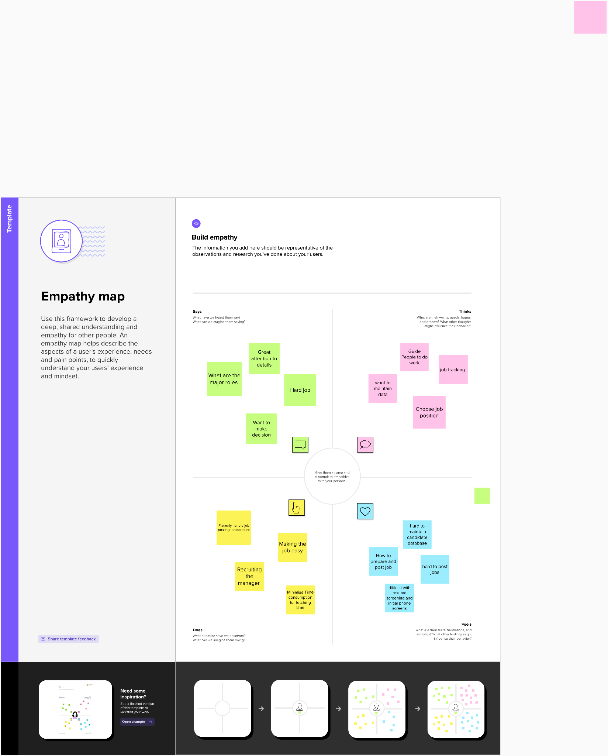



2.2 Ideation & Brainstorming Map 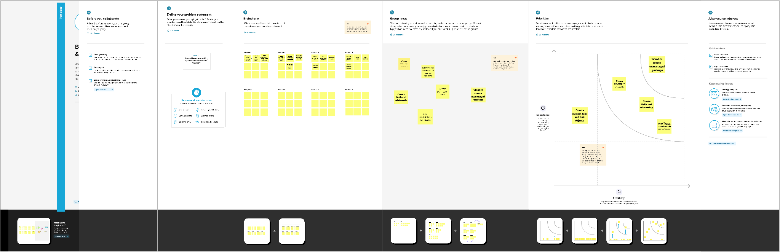

# 3 RESULT

* 1. Data Model:

| **Object name** | **Fields in the Object** |
| --- | --- |
| Job Posting site | | Field label | Data type | | --- | --- | | Job posting site URL | URL | | Status | PICKLIST | | Technical site | CHECKBOX | | Description | TEXT AREA | |
| Reviews | No fields were created |
| Jo  b posting | | Field label | Data type | | --- | --- | | Job Posting site | Master relationship | | Position | Master relationship | |

# 3.2 Activity & Screenshot

## MILESTONE 1

### CREATION OF DEVELOPER ACCOUNT :

### First we created developer account as follows :

A Developer org has all the features and licenses you need to get started with Salesforce.

1. Search Developer.salesforce.com, there we select “ BROWSE TRAILS “, click sign up for developer account

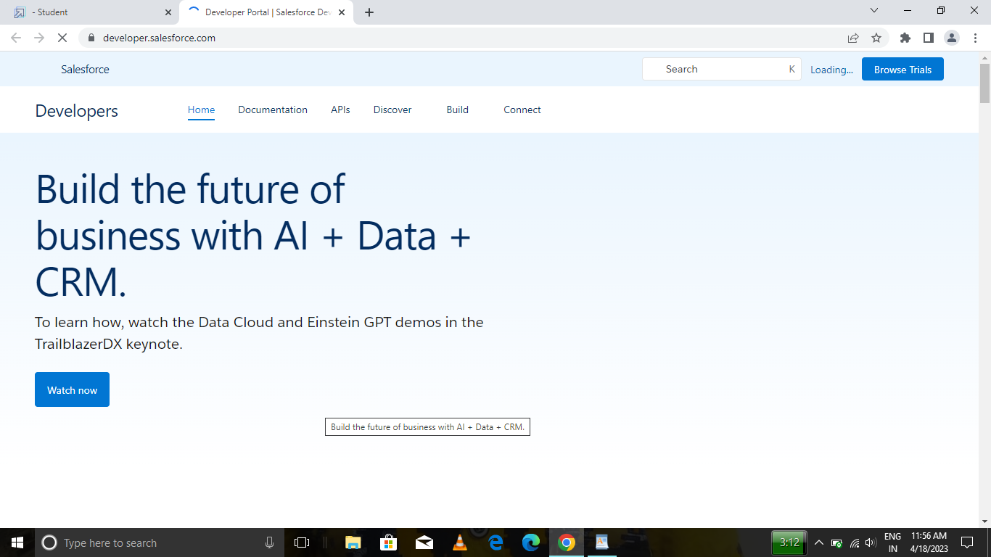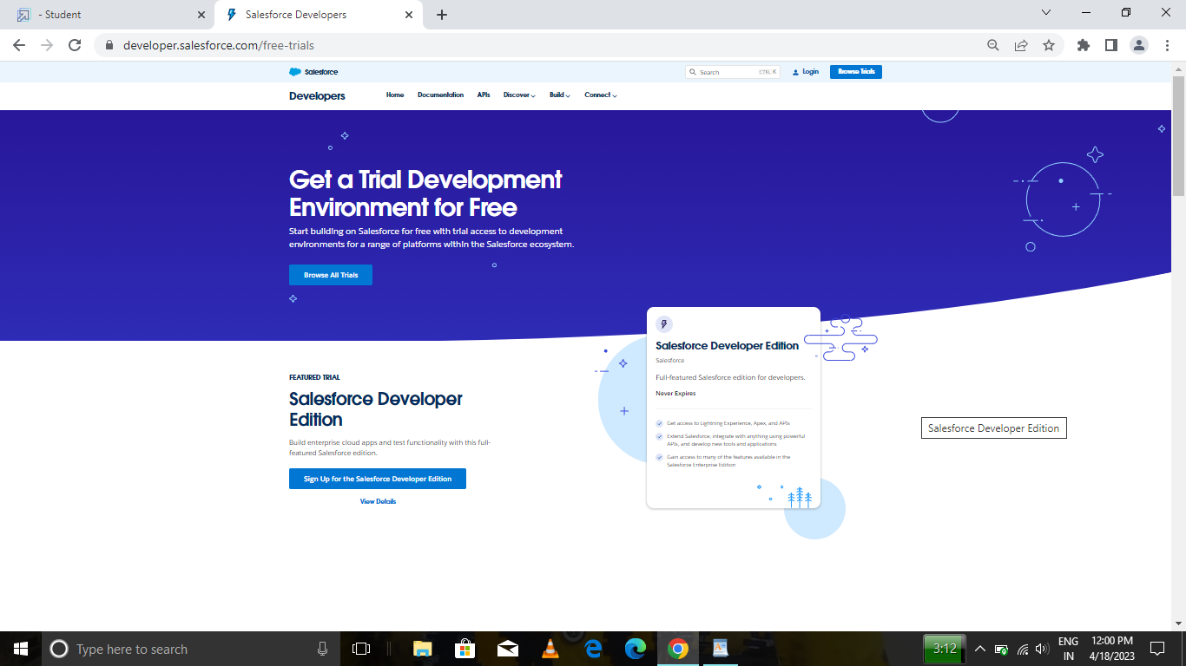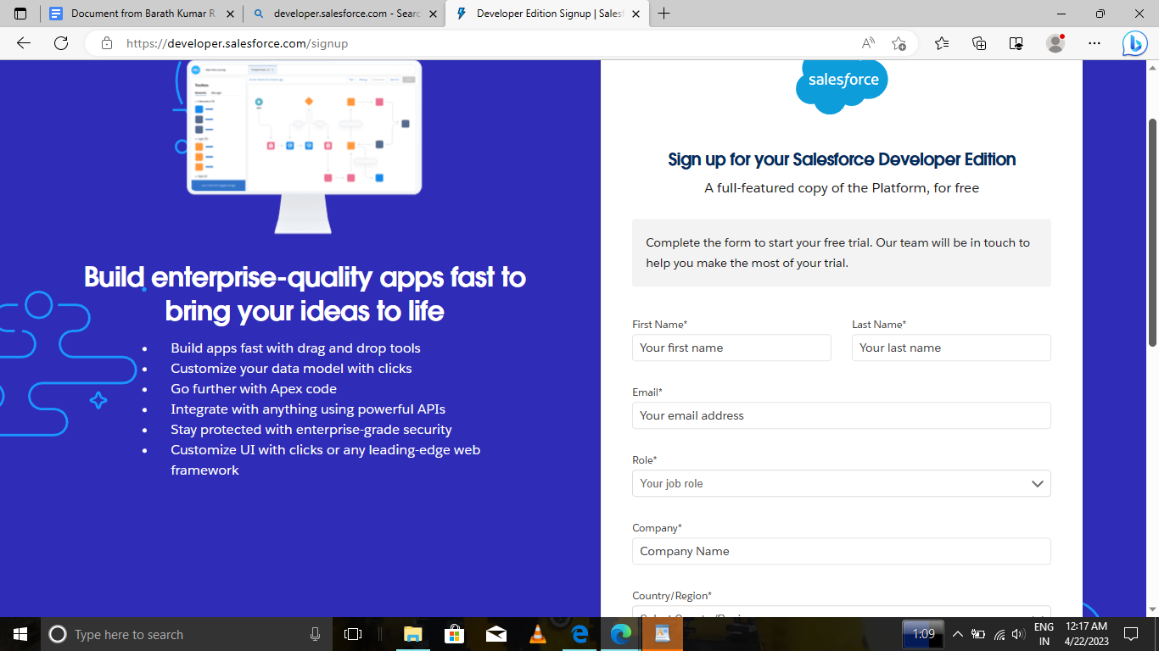

2.Enter the following details like First name, last name, Email, Role, Company, Country/Region, Postal code, and Username must be unique.

3. Click sign me up, After a few minutes you will reserve a mail salesforce org and by using the verify account link you can create your new password.

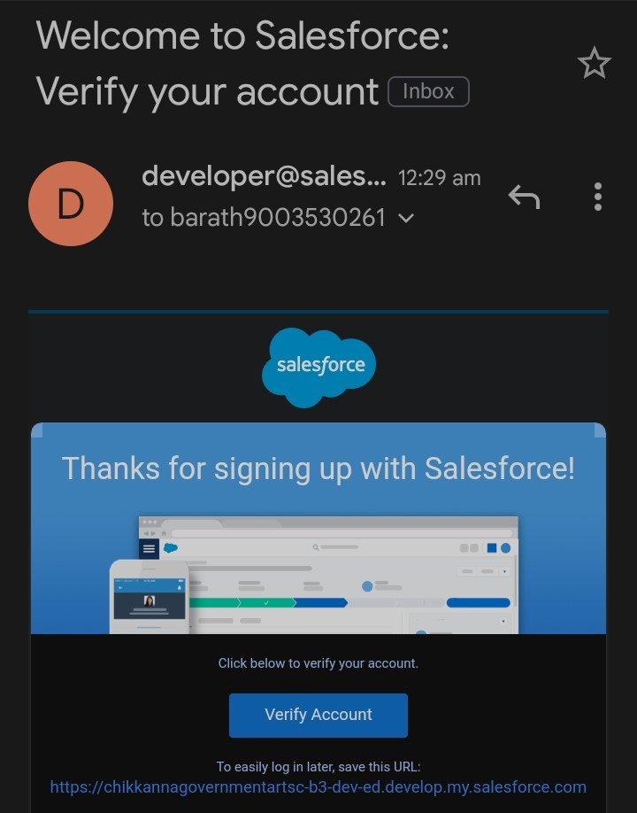

4. Click save.

5. Search login.salesforce.com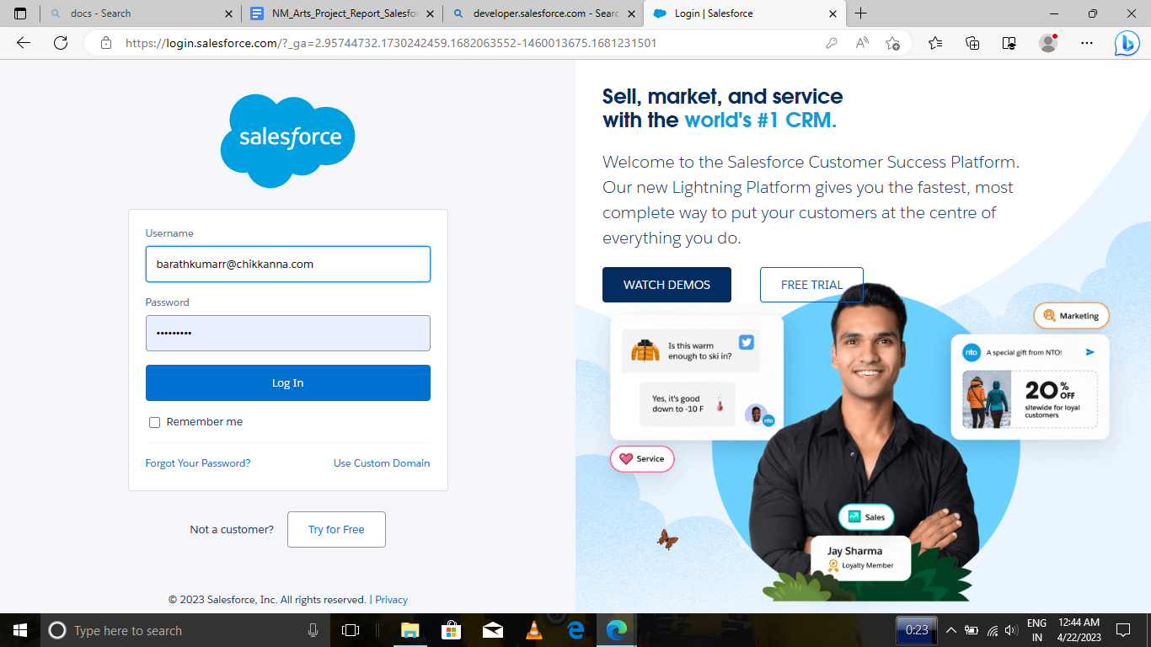

6. By using username and password you can into the salesforce org

here we used usernames such as

1. [barathkumarr@cgac02.com](mailto:barathkumarr@chikkanna.com)
2. [bharath@cgac.com](mailto:bharath@cgac.com)
3. [suriyaprakash@cgac02.com](mailto:suriyaprakash@cgac02.com)
4. [praveenkumars@cgac.com](mailto:praveenkumars@cgac.com)

## MILESTONE 2 :

**PACKAGE INSTALLATION :**

**We normally download package from playground starter but here playground starter is not available so we download the recruiting app from the app exchange**

1. Go to the app exchange and search recruiting app
2. Install the package

## MILESTONE 3 :

Activity-1 Create a custom object for Job Posting Sites

To create a custom object, follow these steps :

1. From setup click on object manager.

2. Click create, select custom object.

3. Fill in the label as "Job Posting Site".

4. Fill in the plural label as "Job Posting Sites".

5. Record name : "Site Name"

6. Select the data type as "Text".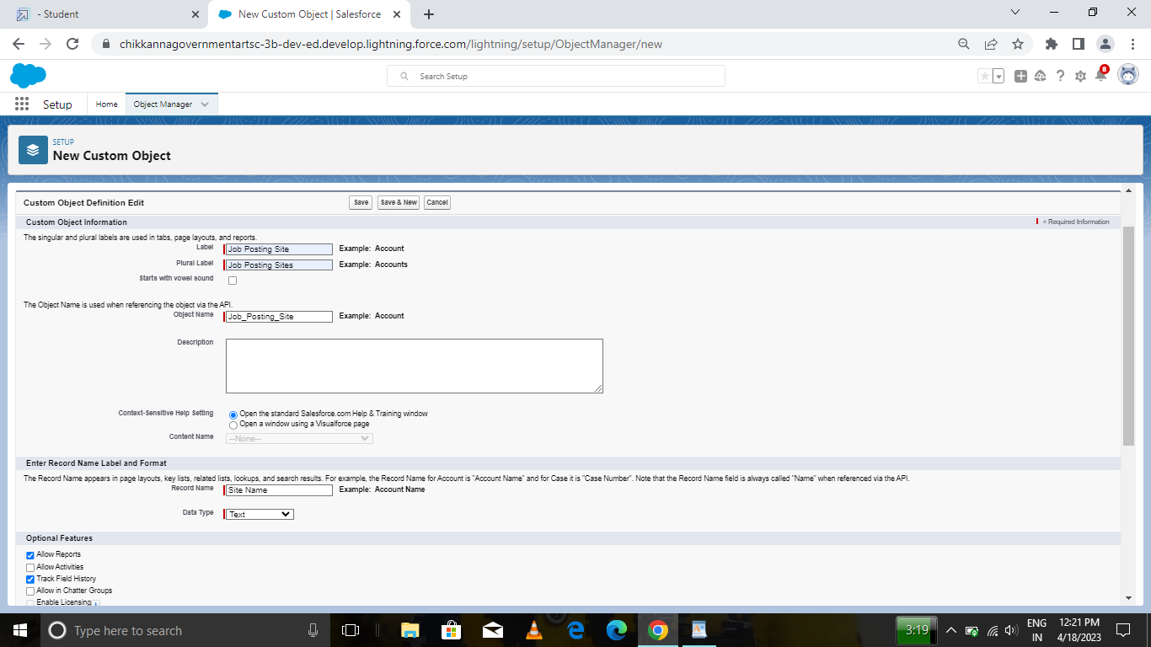

7. In the Optional Features section, select Allow Reports and Track Field History.

8. In the Deployment Status section, ensure Deployed is selected.

9. In the Search Status section, select Allow Search.

10. In the Object Creation Options section, select select these options: Add Notes and Attachments related list to default page layout Launch New Custom Tab Wizard after saving this custom object

11. Leave everything else as is, and click Save.

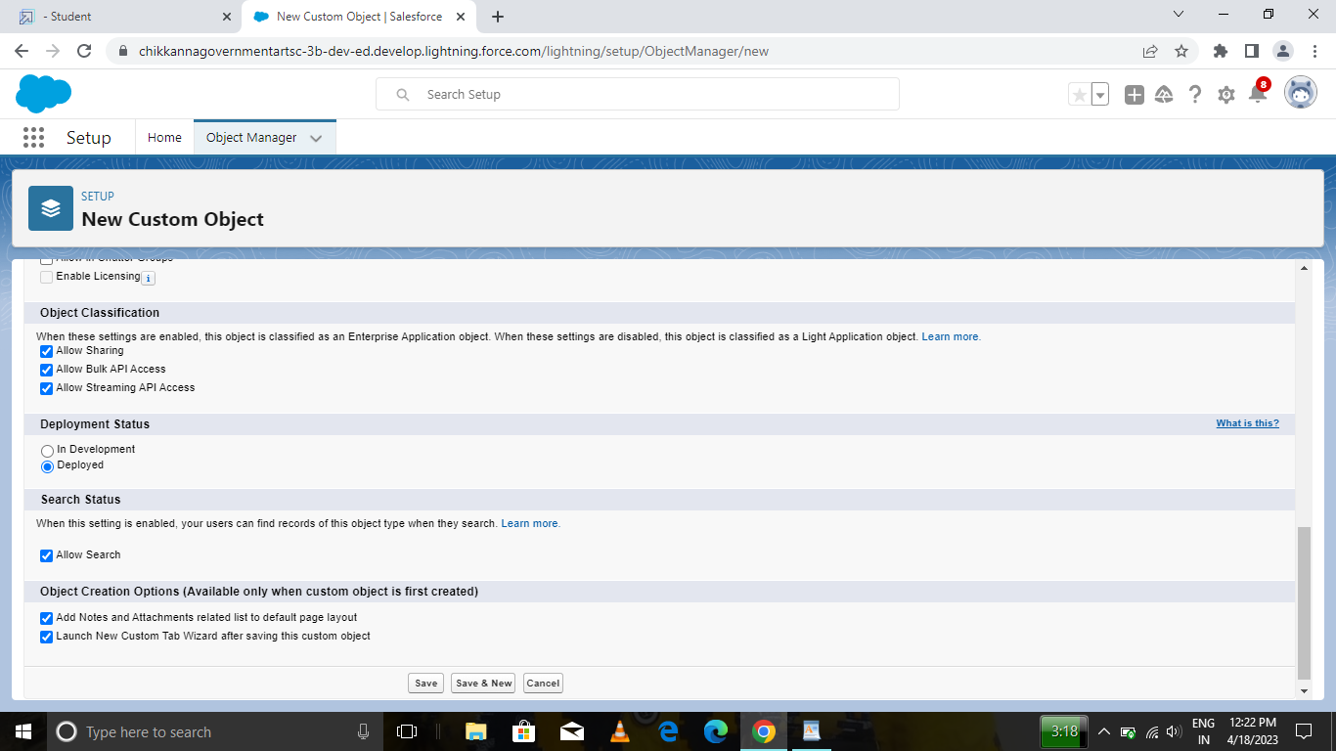

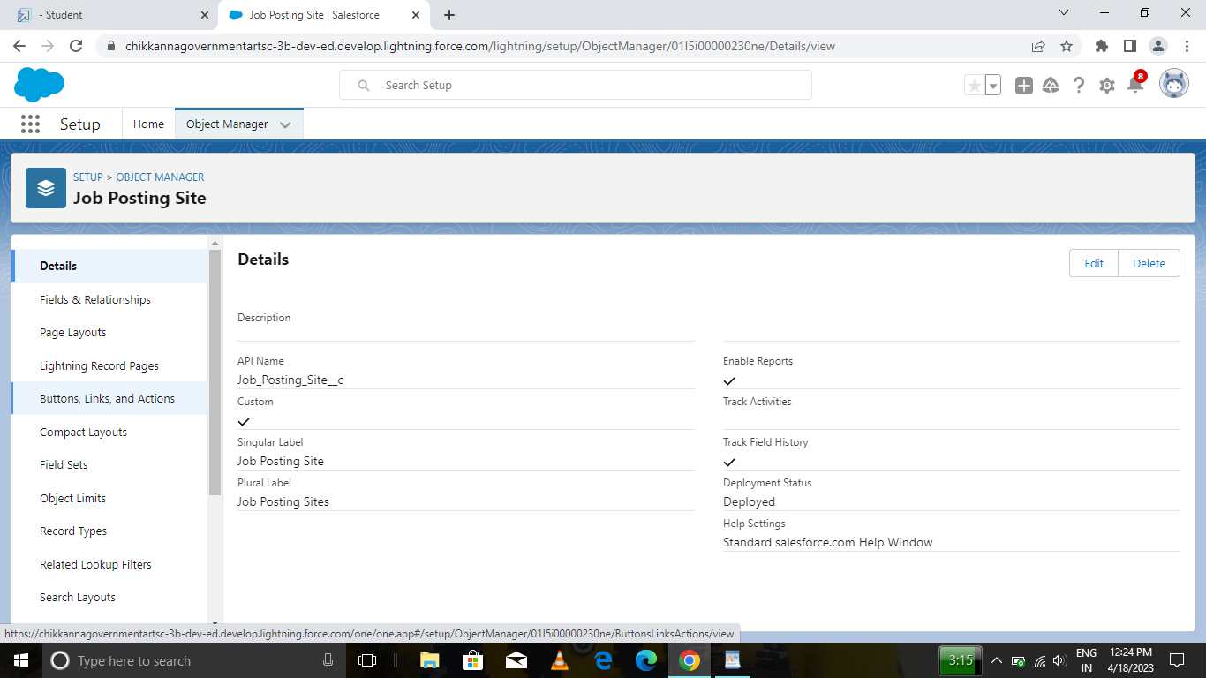

Activity-2 Create a custom object for reviews

To create a custom object, follow these steps :

1. From setup click on object manager.

2. Click create, select custom object.

3. Fill in the label as "Review".

4. Fill in the plural label as "Reviews".

5. Record name : "Review Number"

6. Select the data type as "Auto Number".

7. Under display format enter "REV-{0000}".

8. Enter the starting number as 1.

9. In the Optional Features section, select Allow Reports and Track Field History.

10. In the Deployment Status section, ensure Deployed is selected.

11. In the Search Status section, select Allow Search.

12. In the Object Creation Options section, select Add Notes and Attachments related list to default page layout.

13. Leave everything else as is, and click Save.

## MILESTONE 4 :

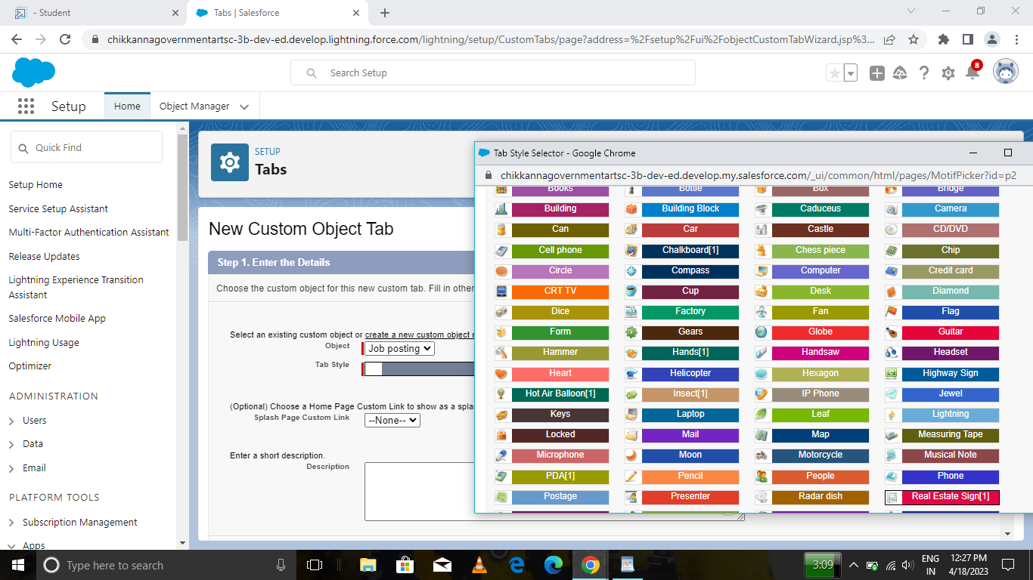

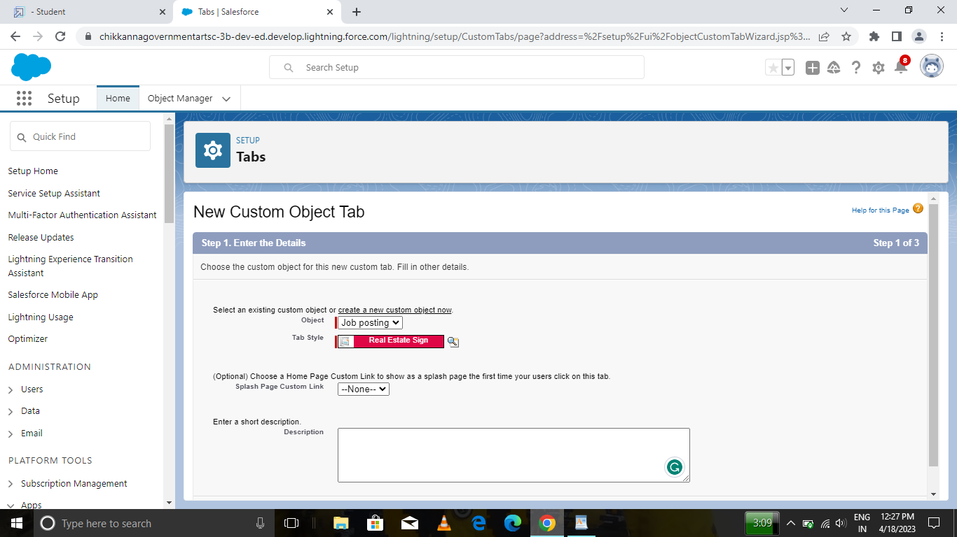Activity :

How to create a tab As we selected to launch a custom tab wizard in step 10, a custom tab wizard appears wherein we customize the look of the Job posting site object's tab.

To do that :

1. To Select the Tab Style: Click the magnifying glass and select Real Estate

2. Click Next.

3. Leave the profile as is and click Next.

4. In the Add to Custom Apps section:

5. Deselect Include Tab. 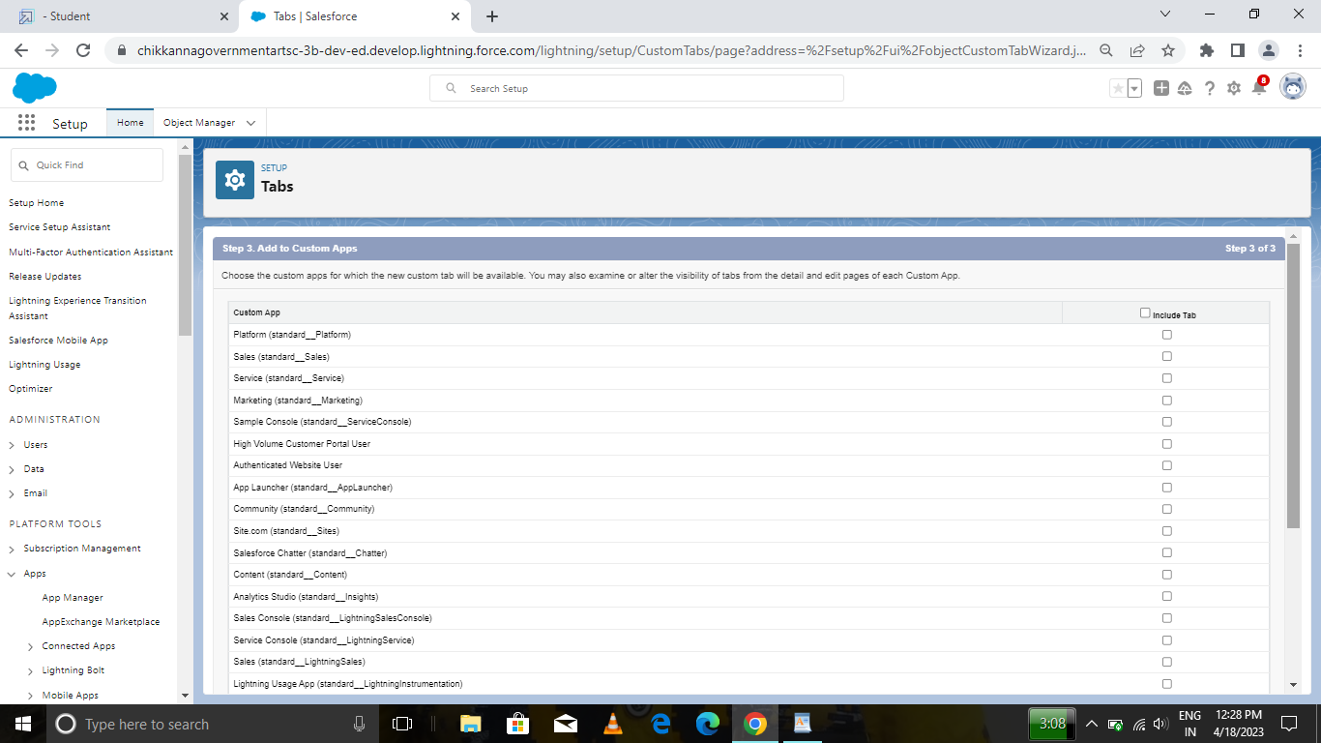

6. Select Append tab to users’ existing personal customizations.

7. Click Save.

## MILESTONE 5

Activity-1 Create New Field for Job Posting site

From the object manager, click on the job posting site, then click on Fields & Relationships. 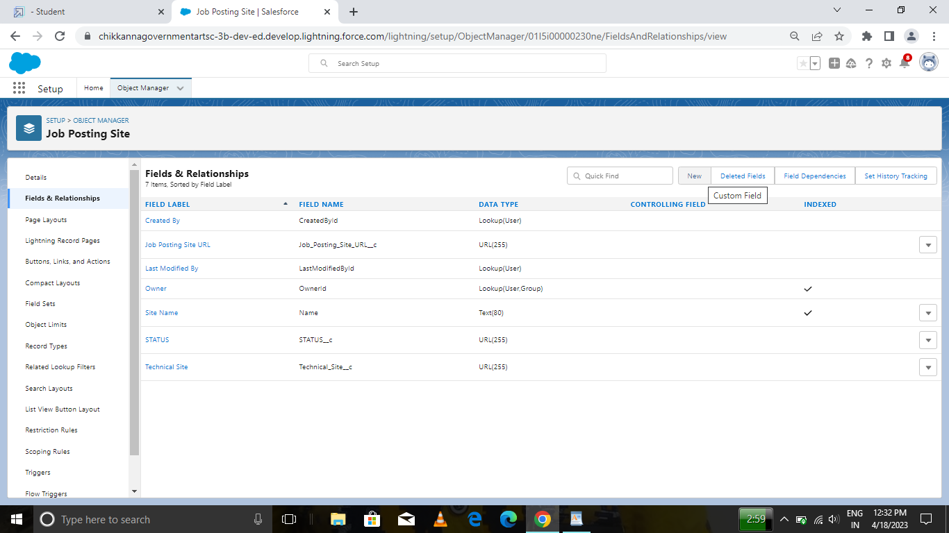

1. Click on new.

2. Select the data type as URL. 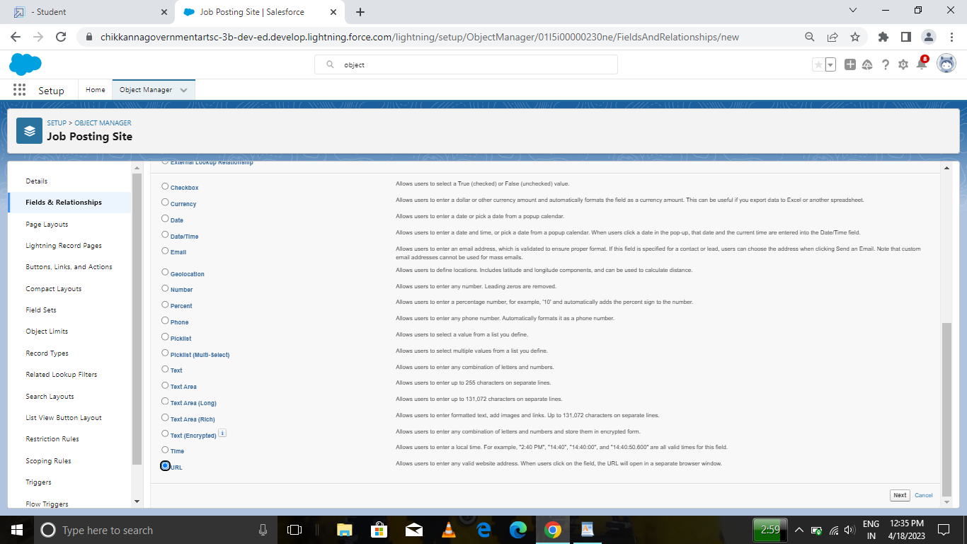

3. Click Next.

4. For Field Label, enter the Job Posting Site URL.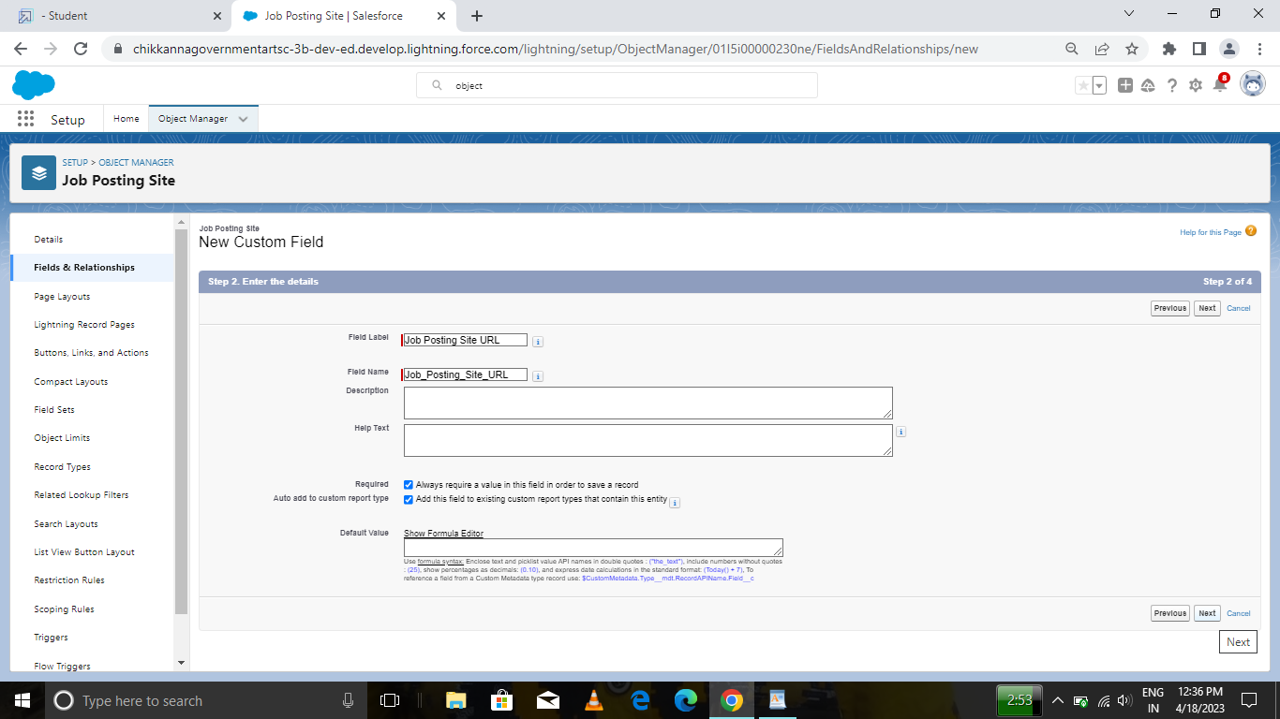

5. Click Next, Next, and click Save & New. 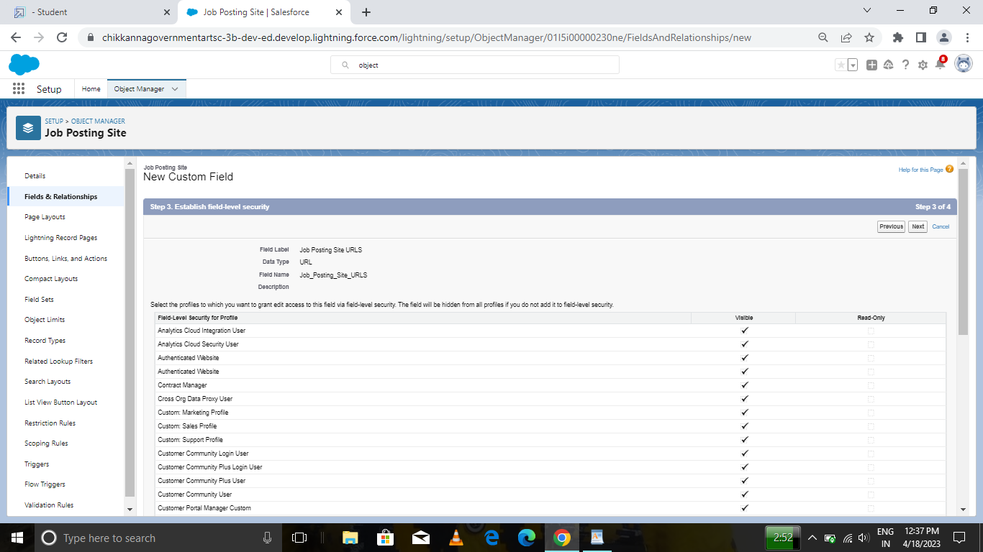

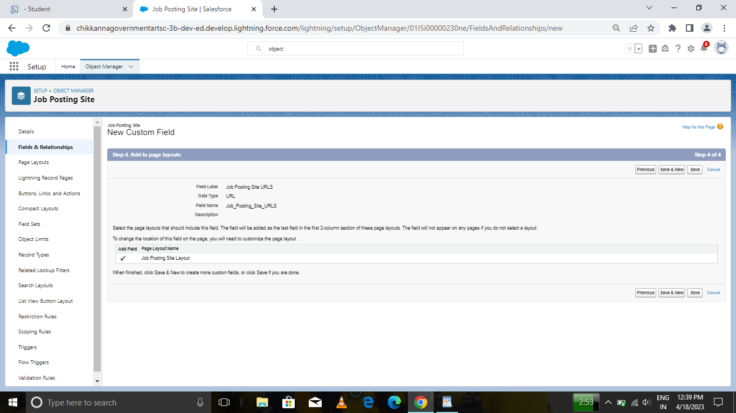

Create a Fields for Job Posting site

1. Status (PICKLIST)

2. Technical site (CHECKBOX)

3. Description (TEXT AREA)

## MILESTONE 6 :

Activity Creating a custom junction object :

1. From setup, click object Manager.

2. Click create, select custom object.

3. Enter the label as "Job posting".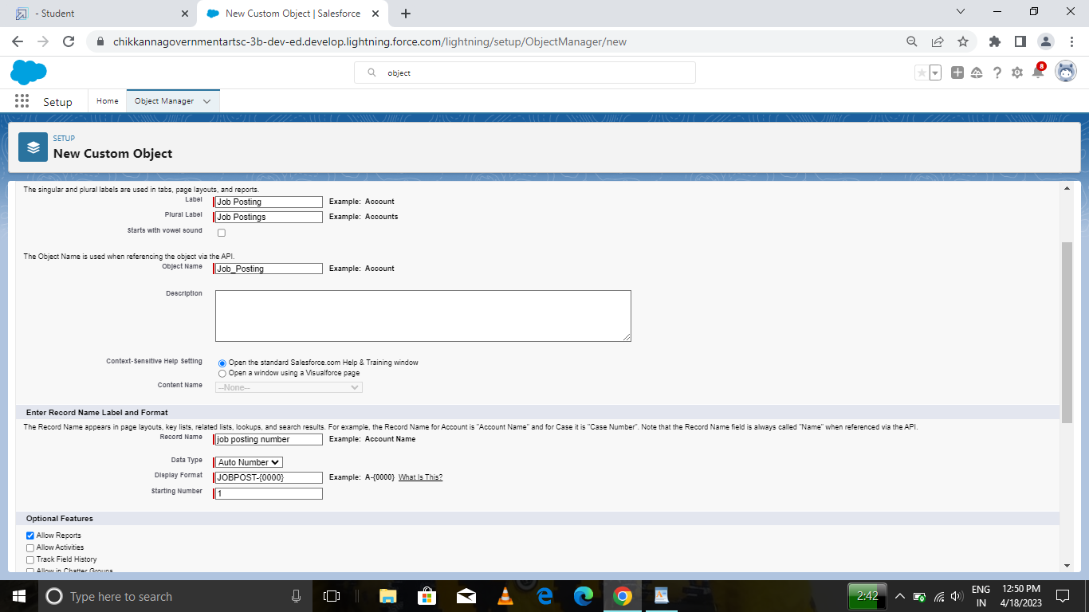

4. Enter the plural label as "Job postings".

5. Enter the record name as "Job posting number".

6. select the data type as "Auto Number".

7. Enter the display format as "JOBPOST-{0000}"

8. Enter the Starting number as 1.

9. Leave everything else as is, and click save.

Activity: 2

Create a Relationships Object Creating a master-detail relationship between Job posting and job posting site.

1. From setup, click object manager.

2. Select Job posting object, click on field and relationships, click new.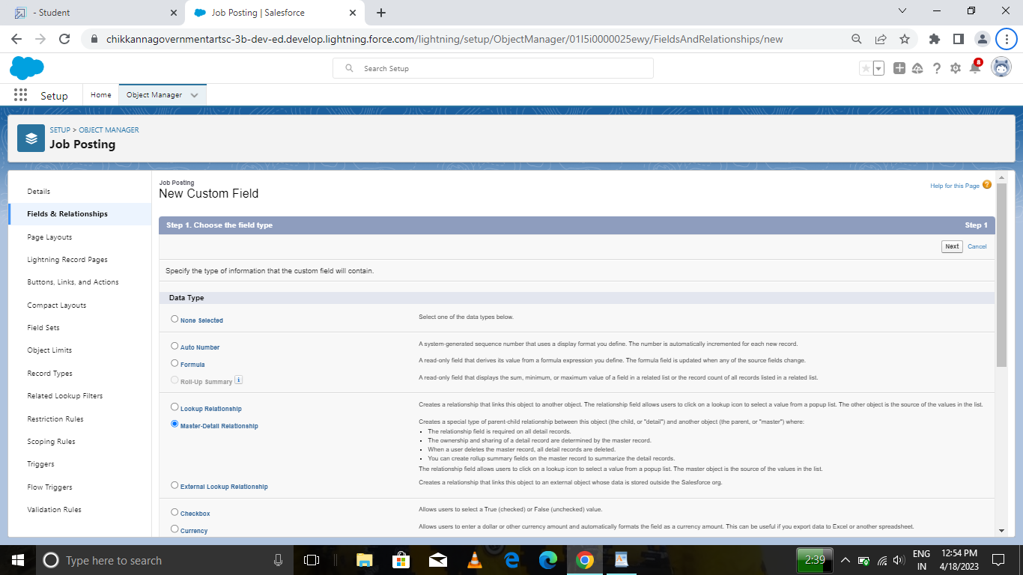

3. Select the data type as Master-detail relationship.

4. Click Next, relate to the Job posting site.

5. Enter the label Job Posting site.

6. Click next, next, next and save.

Creating a master-detail relationship between job posting and position.

1. From setup, click object manager.

2. Select Job posting object, click on field and relationships, click new.

3. Select the data type as Master-detail relationship.

4. Click Next, relate to position. 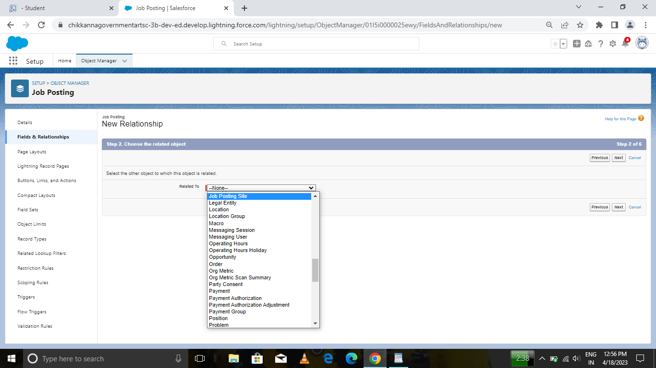

5. Enter the label Position.

6. Click next, next, next and save

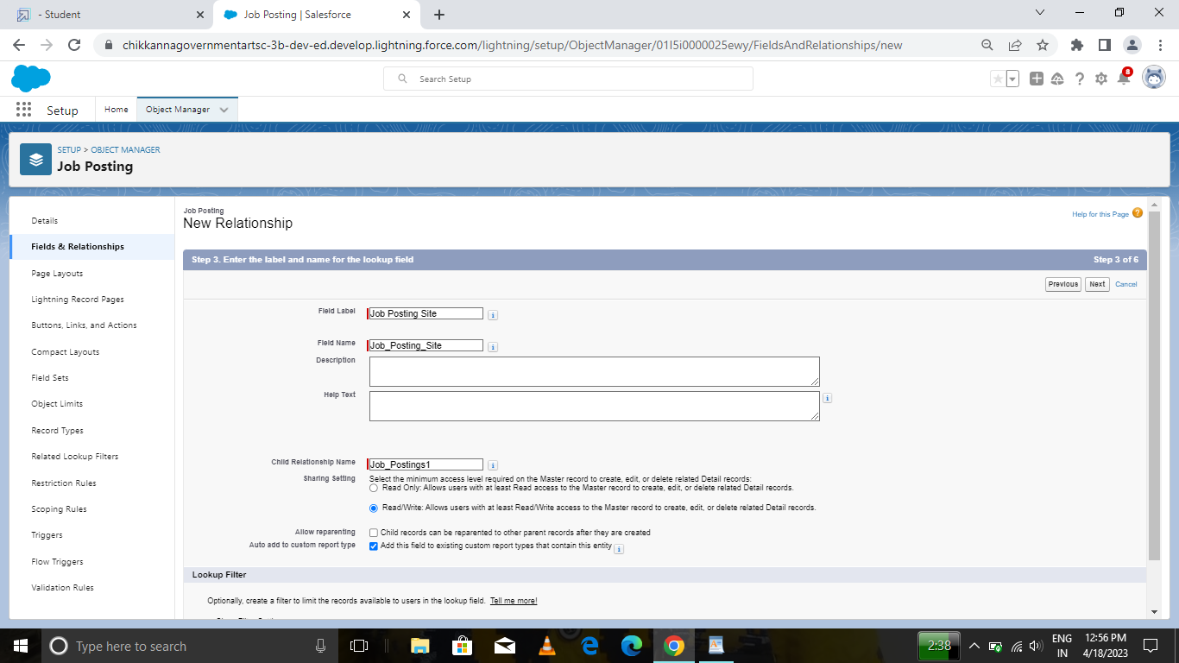

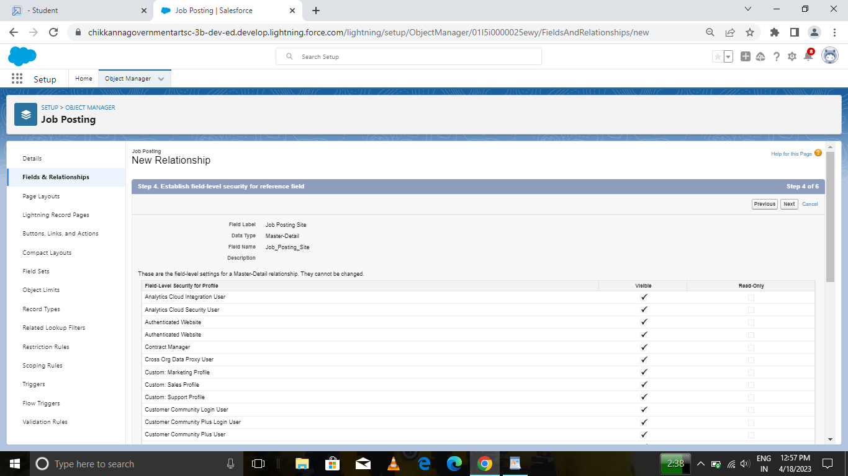

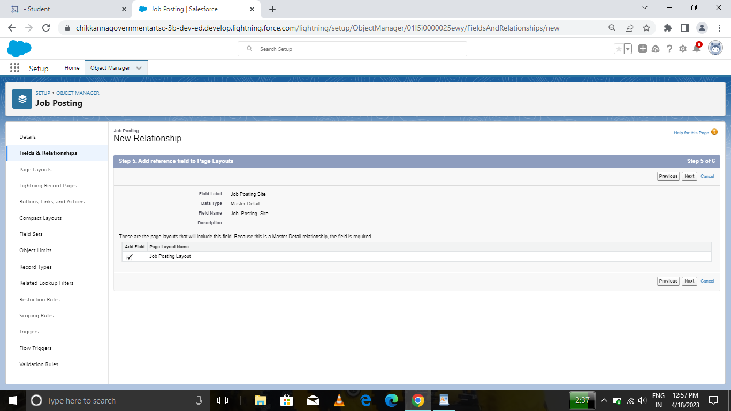

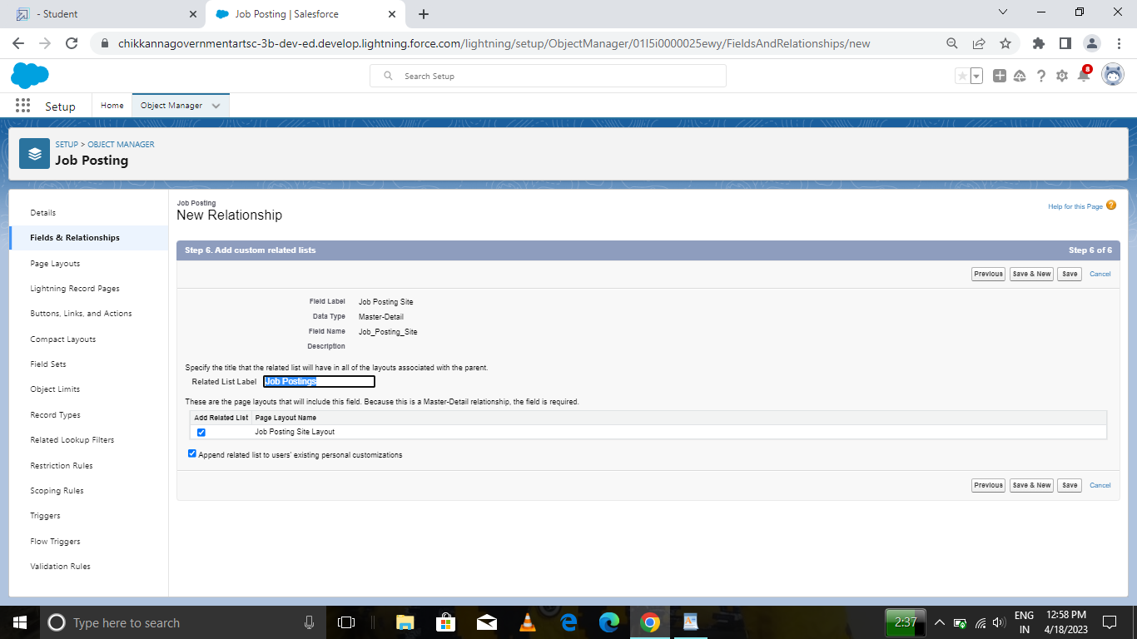

## MILESTONE 7 :

Activity-1 Modifying the page layouts :

1. From setup, click on object manager.

2. Click position, then page layouts. 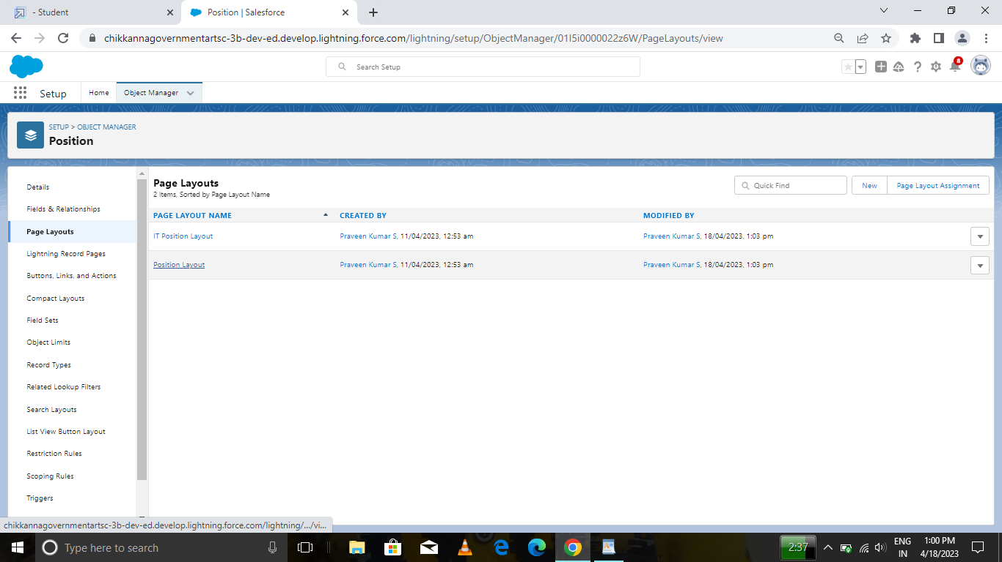

3. Click the array next to the position layout and select edit.

4. Scroll down to the job posting related list, and click the wrench icon in the header to edit it.

5. From the available fields section, select Job posting site : Status Job posting site : Technical Site

6. Click add. 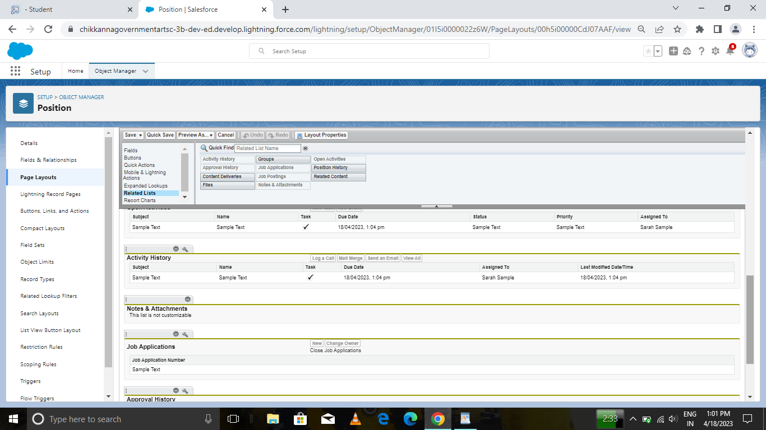

7. From the selected fields section, select job posting : Job posting number and click remove.

8. Click ok, then save.

Activity-2

Create a Page layout for Review Object

## MILESTONE 8 :

Activity -1

Creating a Validation Rule:

To create a validation rule: Go to object manager, select the object on which validation rule has to be implemented, scroll down and click validation rule, New.

Give details as: 1. Rule name: Phone number validation rule.

2. Active: checked

3. Description: phone number should not be more than or less than 10 digits.

4. Under Error Condition Formula: write the condition using insert field, insert operator, insert function

5. Using check syntax: check if the formula you entered is valid or not. 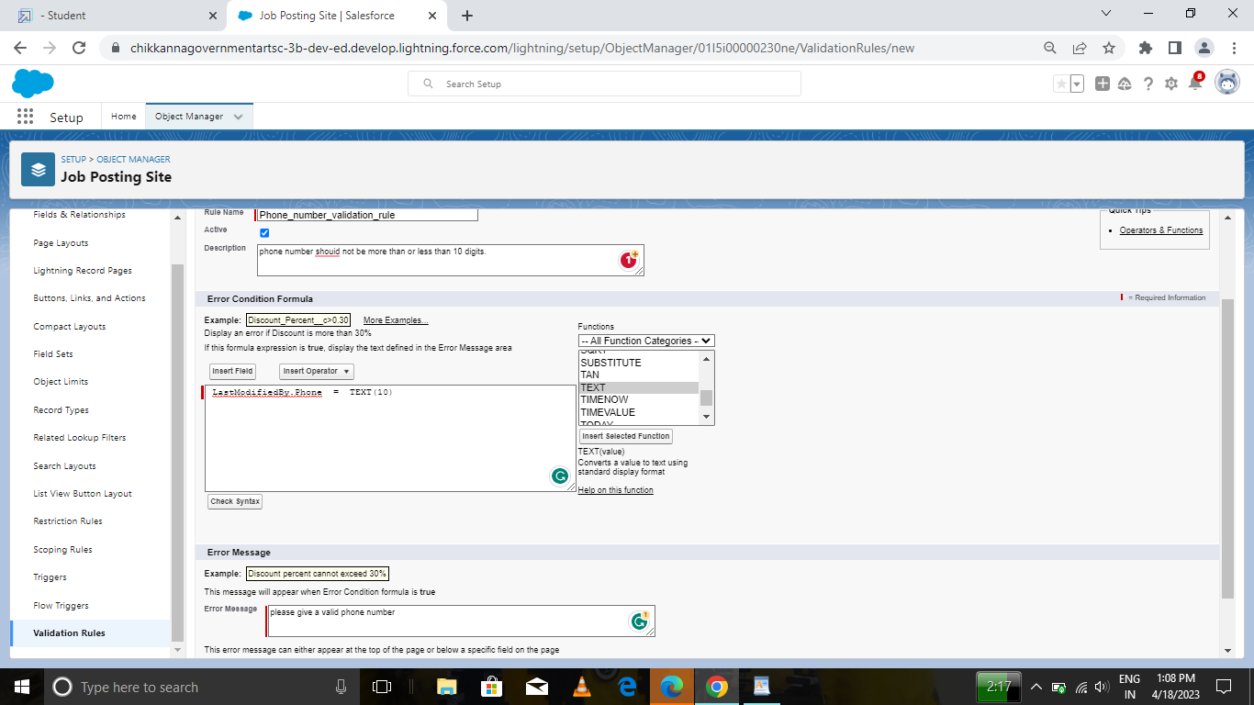

6. Error Message: Please give a valid phone number

7. Error location: select field

8. Save

Activity-2

Create a Validation rule For Technical Site Checkbox is equal to True.

## MILESTONE 9 :

Activity Creation on profile: From Setup enter Profiles in the Quick Find box, and select Profiles.

1. From the list of profiles, find Standard User.

2. Click Clone.

3. For Profile Name, enter Event user profile.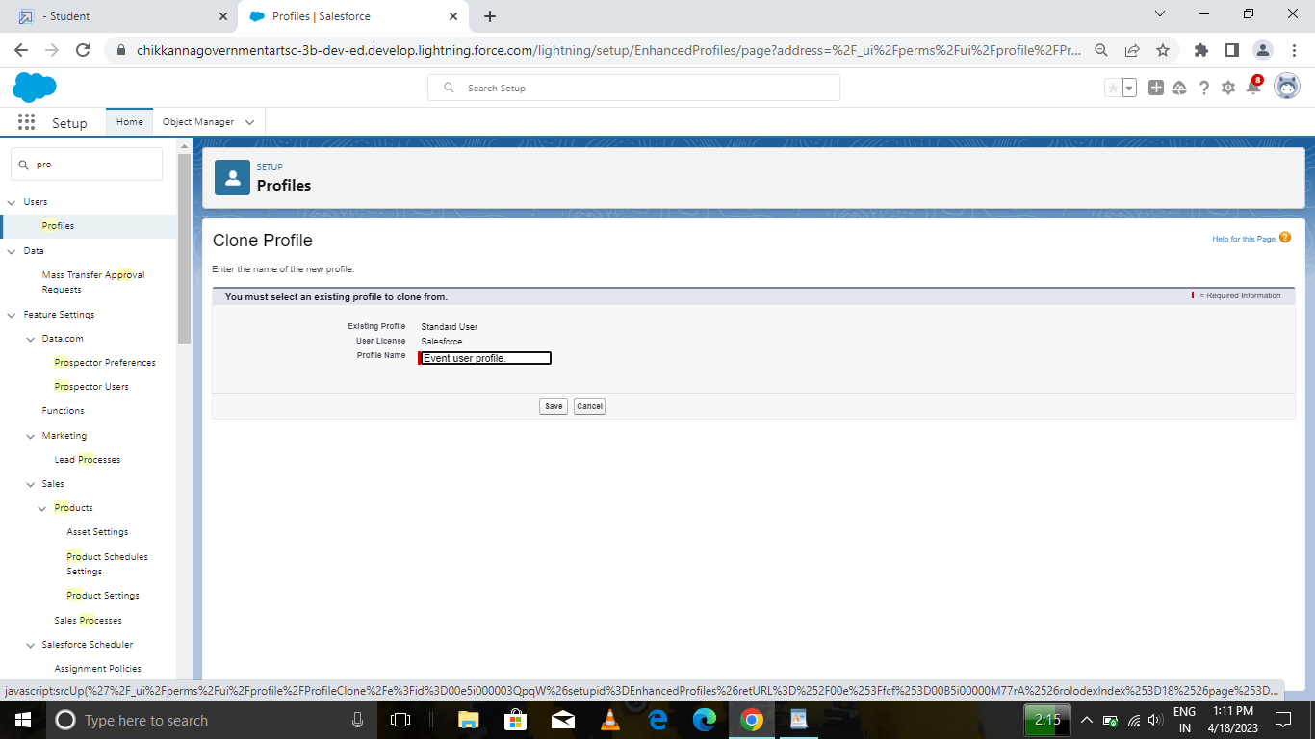

4. Click Save 5. While still on the Event profile page, then click Edit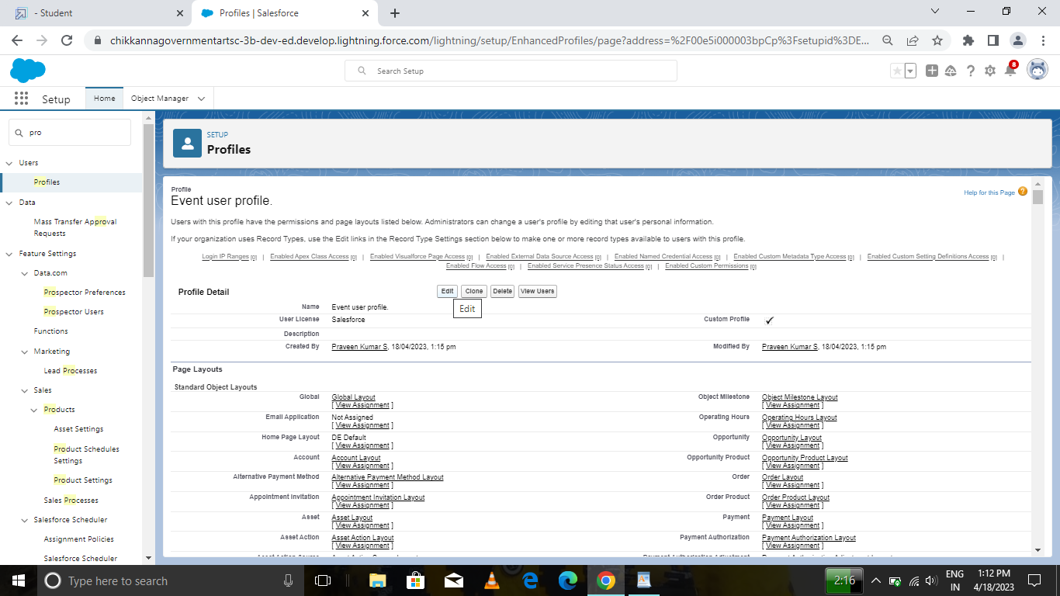.

6. Scroll down to Custom Object Permissions and View all 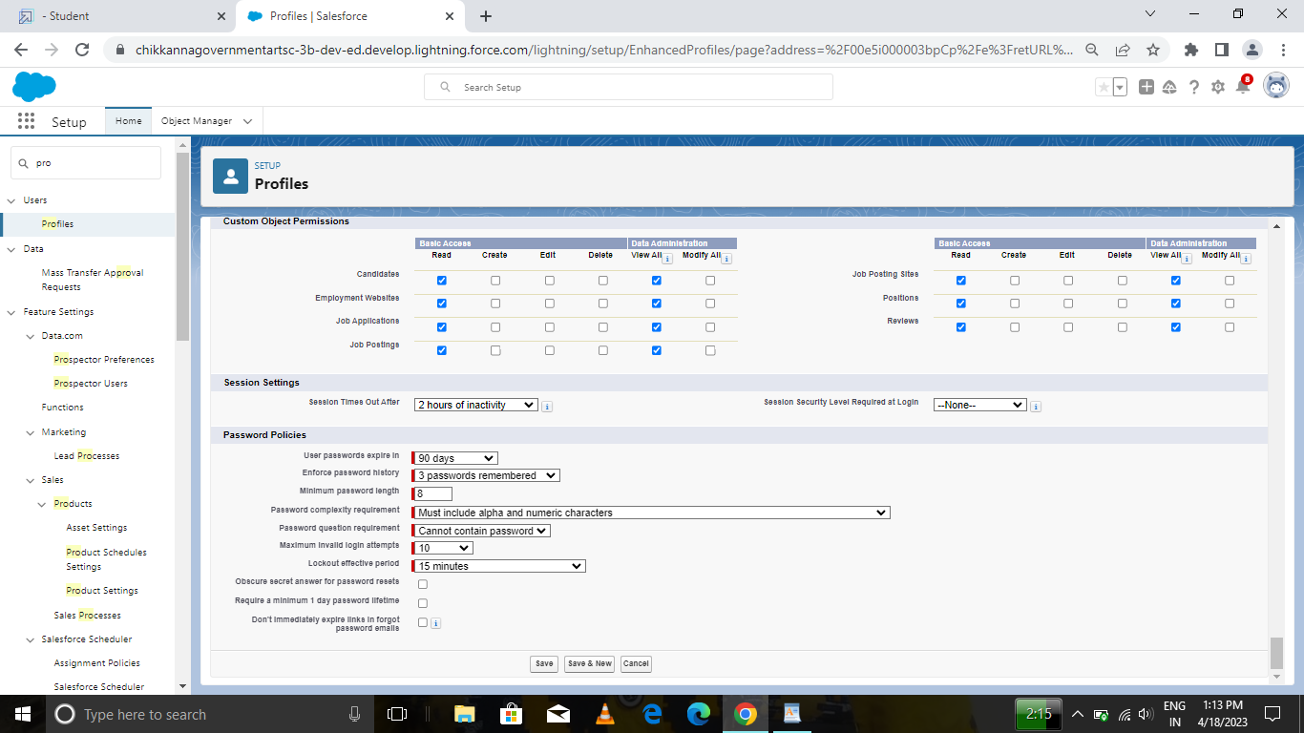

Activity-2

Create a profile with the profile name as “Sales profile”.

## Milestone 10 :

Activity-1

Creating a User: From setup type “users” in quick find and select users, then click New User

· First Name: Sanjay

· Last Name: Gupta

· Alias: Sanj

· Email: provide your personal email id for future reference ·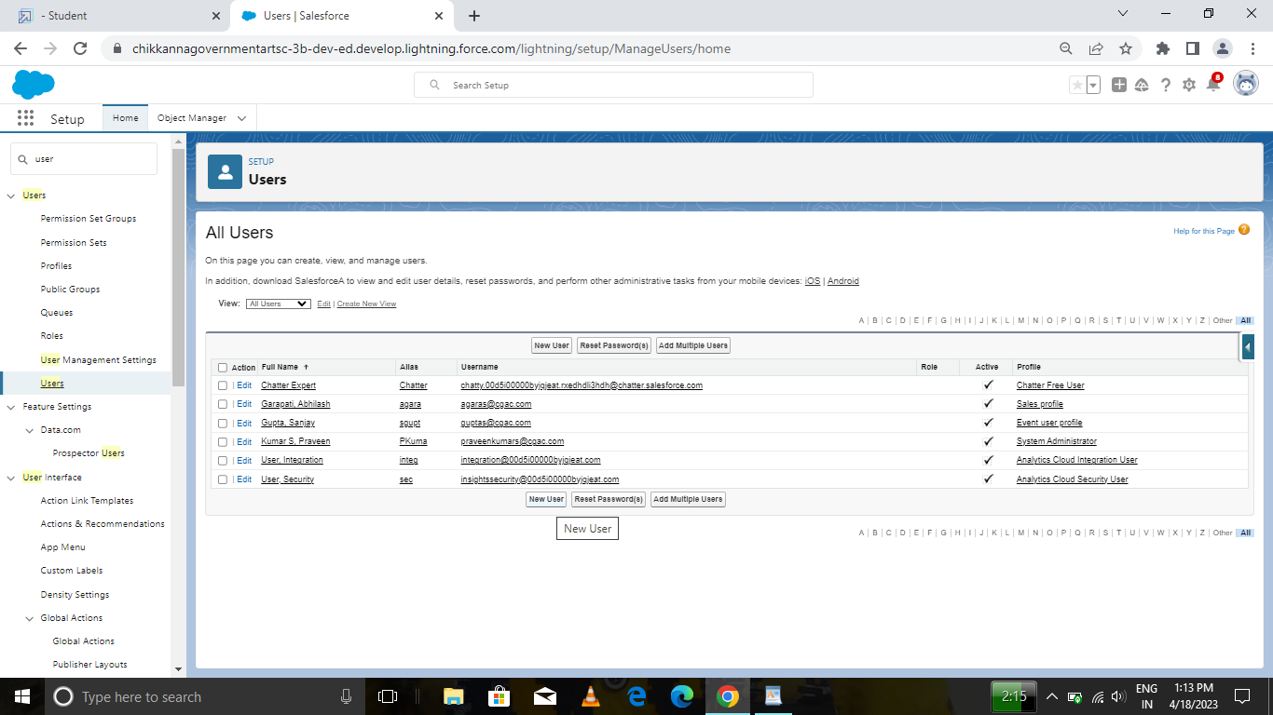

Username: [sangupta@barath.com](mailto:sanjaygupta@thesmartbridge.com)

· Nickname: Sanju

· Role: leave it as default

· User License: Salesforce · Profile: Event User Profile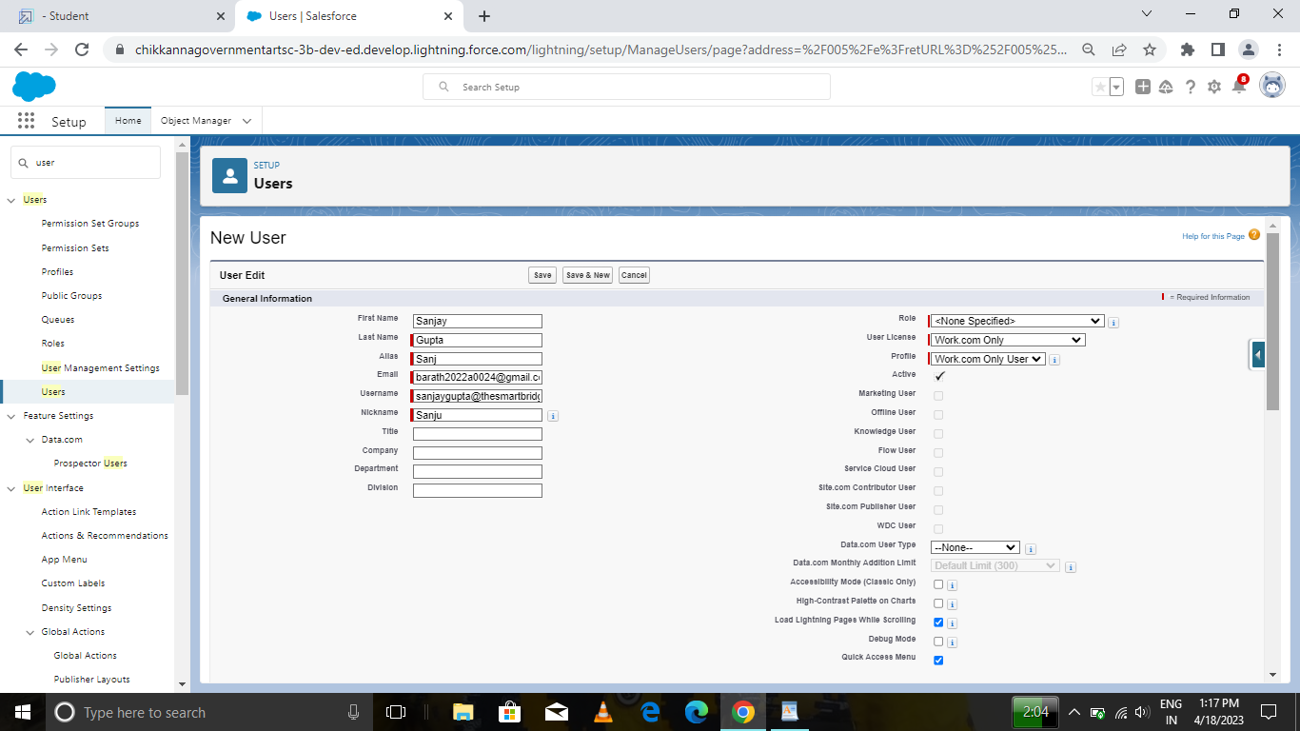

Activity-2

Create a user with a username as “Abhilash Garapati”, and assign him the sales profile

## MILESTONE 11 :

Activity-1

Creating a Permission Set:

1. From setup search “permission sets” in quick find and select permission set then click on New. 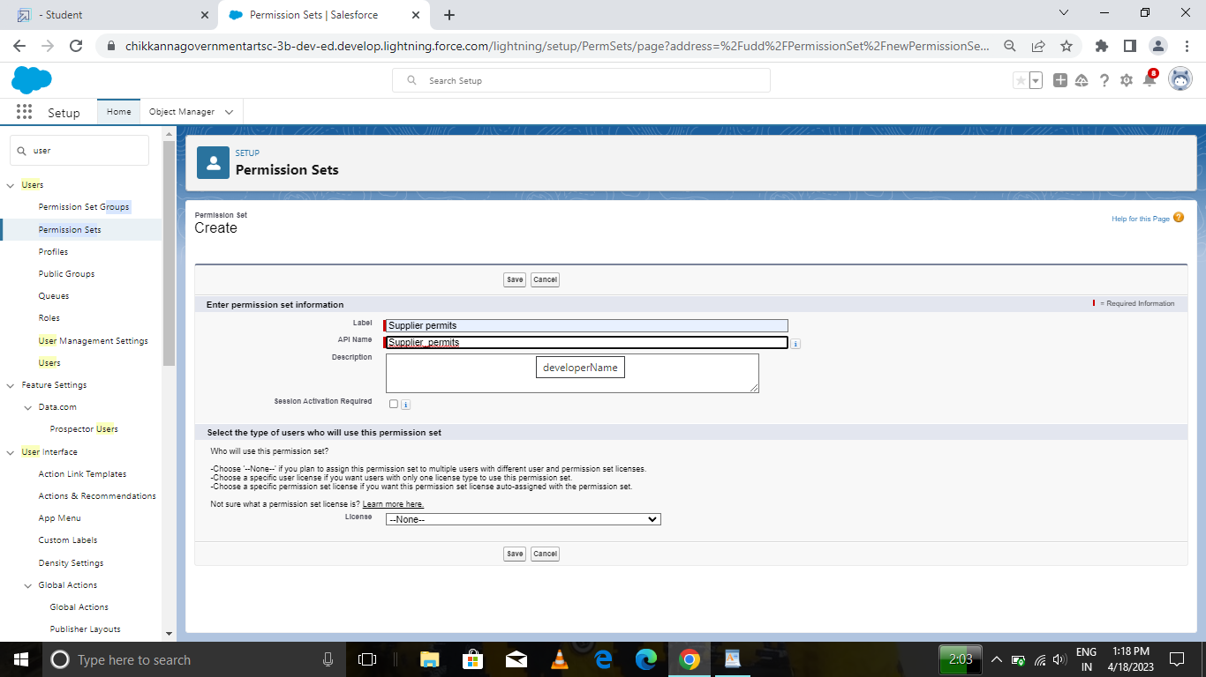

2. Enter label as: Supplier Permits and Save.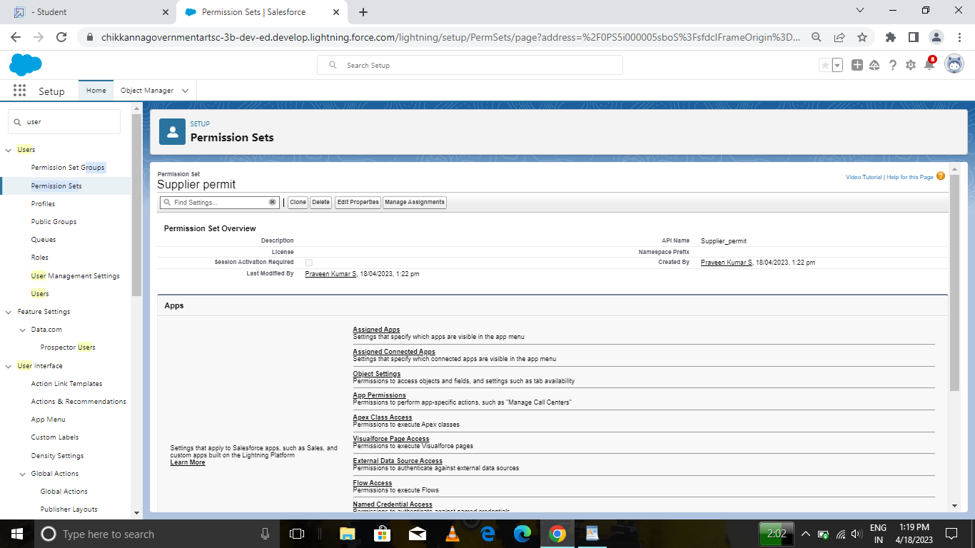

3. After saving the permission click on the Manage assignment

4. Now click on the Add Assignment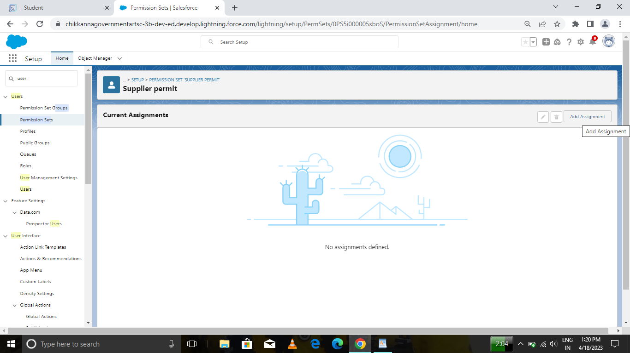

5. Now select the users and click on save Activity-2 Create a Permission set for Review object

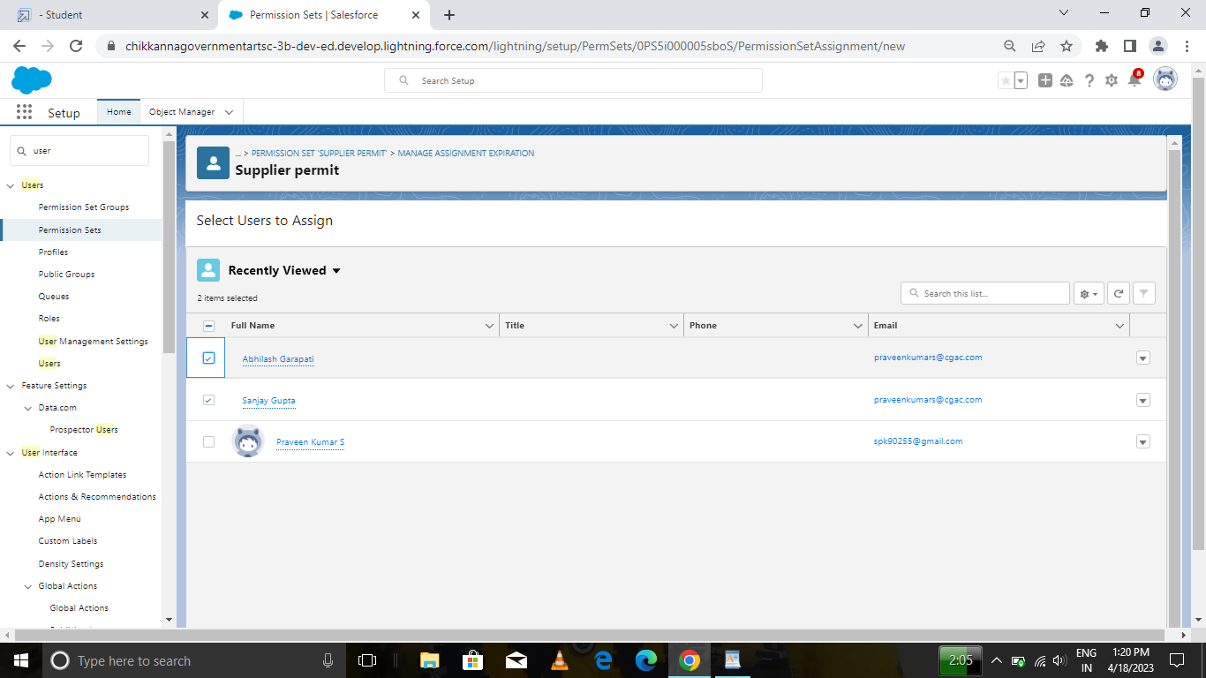

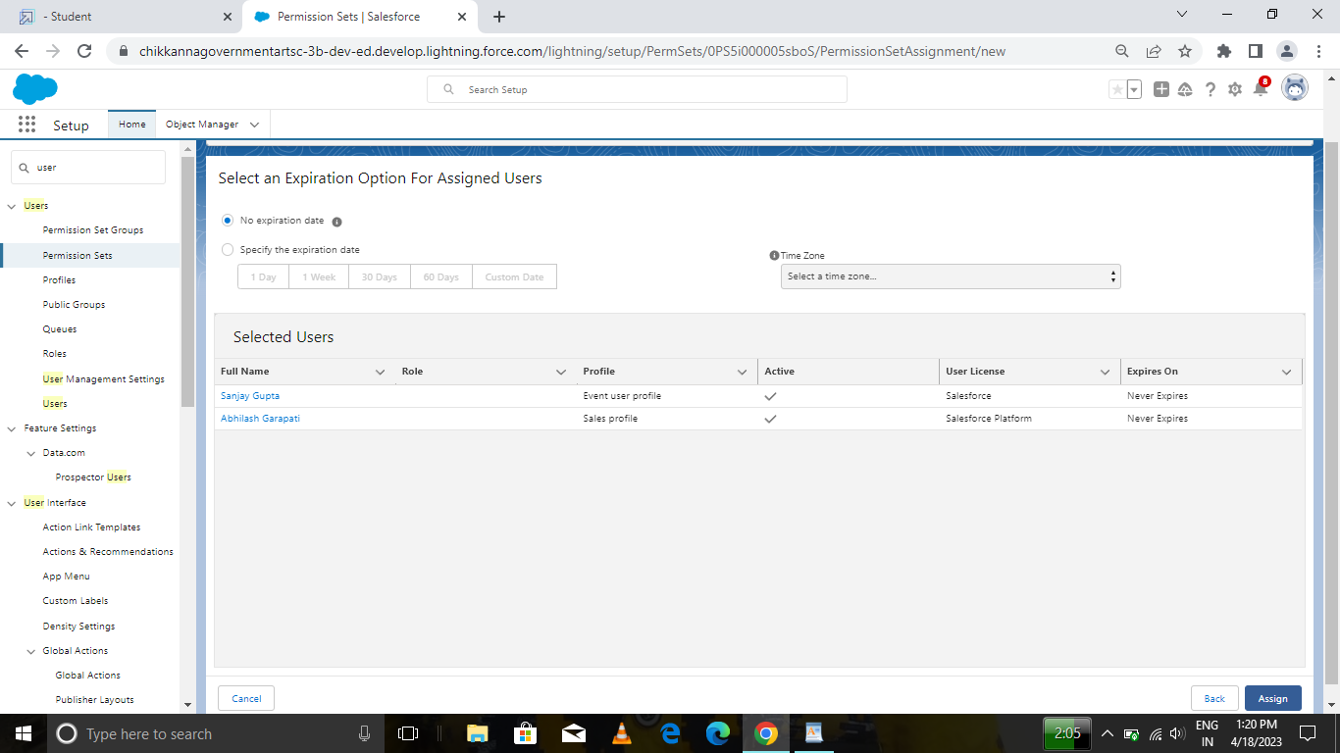

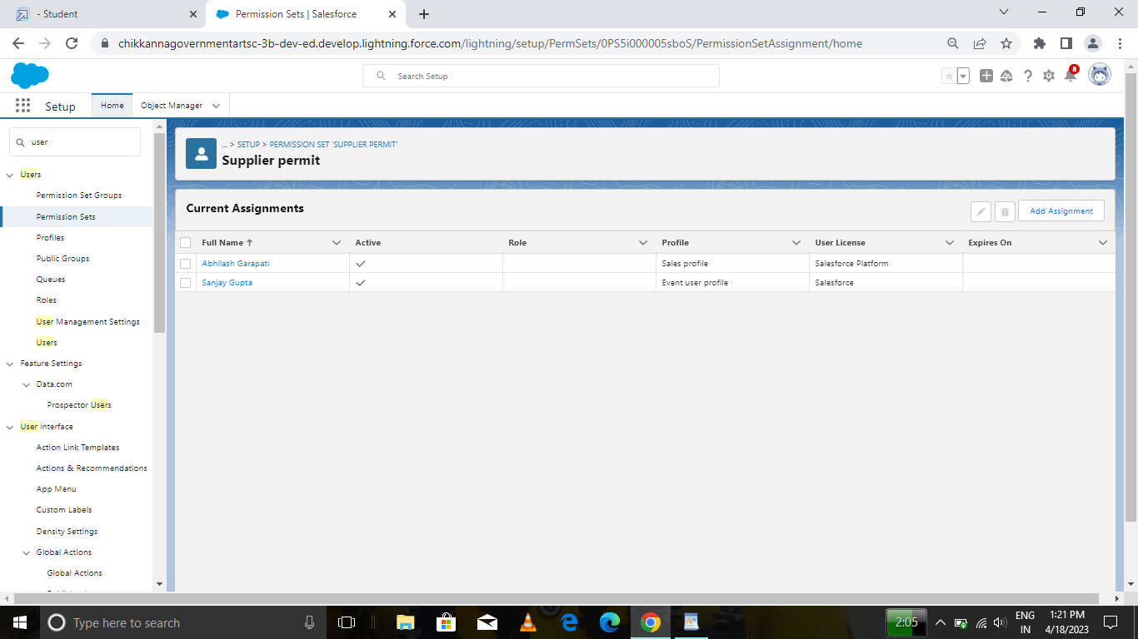

## MILESTONE 12 :

Activity-1 :

1. From the Reports tab, click New Report.

2. Select the report type Attendees with events for the report, and click Create.

3. Customize your report accordingly and include all fields, then save or run it.

Activity-2

Create a report for review and Job Posting Objects

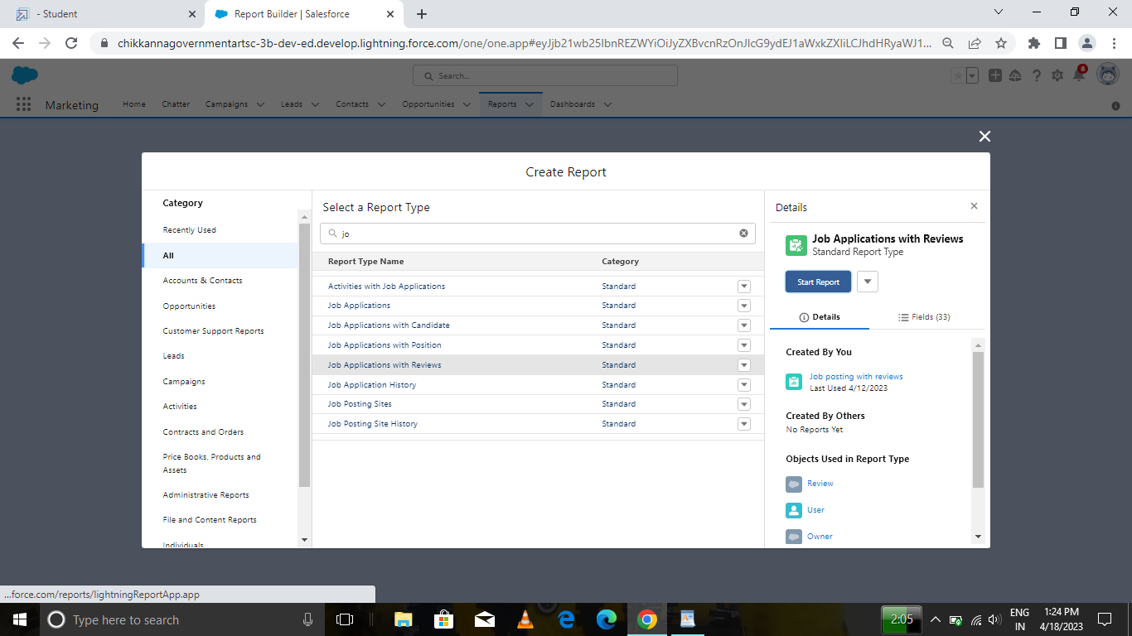

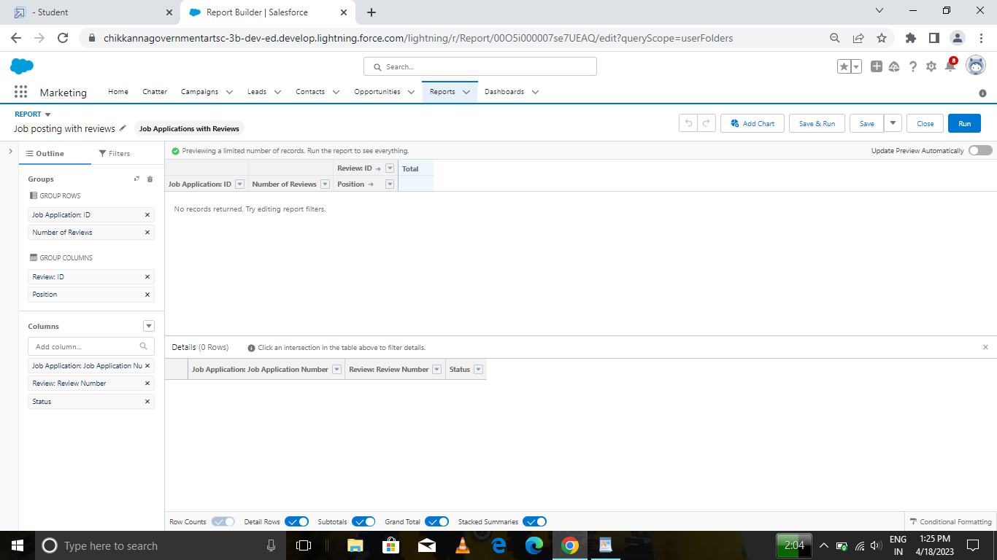

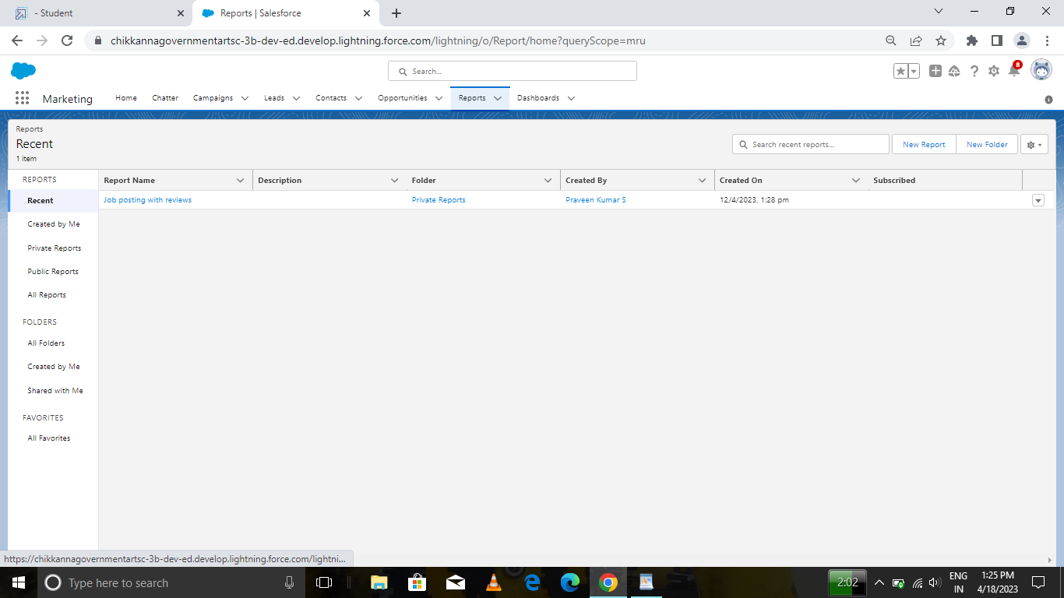

# **Trailhead Profile Public URL**

**Team Lead -** [**https://trailblazer.me/id/bkumarr15**](https://trailblazer.me/id/bkumarr15)

**Team Member 1 -** [**https://trailblazer.me/id/bhare21**](https://trailblazer.me/id/bhare21)

**Team Member 2 -** [**https://trailblazer.me/id/surip1**](https://trailblazer.me/id/surip1)

**Team Member 3 –** [**https://trailblazer.me/id/pkumars65**](https://trailblazer.me/id/pkumars65)

# **ADVANTAGES & DISADVANTAGE**

### Human Resource Planning

Human Resource Management(HRM) helps in estimating the right number of people required for carrying out the necessary activities of an organization. It analyses different work positions within a business for identifying the skill sets needed for such positions. Proper information regarding job designations helps in acquiring the right peoples.

### Hiring Workforce

It enables business in hiring skilled and qualified workforce by creating a large pool of competent peoples. Human Resource Management conducts whole recruitment process of an organization in accordance with the requirements of job positions.

### Retaining Employees

Human Resource Management plays an efficient role in retaining skilled employees for a longer term within an organization. It monitors working environment provided to workers and ensures that they get hygienic working place, better remuneration, extra benefits and facilities. This leads to long term associations of workers with organization.

### Enhance Organization Effectiveness

Human Resource Management influences the overall productivity and profitability of a business organization. It is the one which monitors the allocation of all resources and ensures that they are full utilized with minimum wastage. Human Resource Management matches right person with right job which improves the effectiveness of an organization.

### Handles Disputes And Queries

It handle disputes and resolves all queries of workforce from time to time. Human Resource Management leads to smooth functioning of an organization by redressing all problems of employees in a better manner.

### Motivating Employees

Motivation of employees towards their roles is must for achieving the desired goals and objectives. Human Resource Management motivates workforce by rewarding them as per their performance and providing welfare facilities. It examines their output level for deciding their incentives which boost the overall morale of workers.

### Improves Employee Relations

HRM focuses on establishing good relations among management and labors for ensuring continuity of business. It provides fair remunerations to workers and take cares of all their necessities. Human Resource Management builds up better coordination in between employer and employees by considering their ideas and suggestions in policy making.

Disadvantages of Human Resource Management

### Costly Setup

Human Resource Management systems require huge costs for installation within the business origination. Owners need to give proper training to its workers for setting up and running these systems. Small businesses can’t afford to run these systems within their operations.

### Recent Origin

Human Resource Management lacks universal approval academic base due to its recent origin. There is no uniformity in its terms and different people characterize the term in a distinct way. Organizations are renaming their workforce department as HRM which may not yield real results. It requires changes at a fundamental level in approaches, mentality and philosophy of management.

### Unpredictability

Another major limitation is inability to predict the external events and behavior of peoples. HRM needs a full support of all working people and top management in an organization for its successful implementation. In absence of proper support from top management, it may not yield expected results.

### Improper Development Programmes

HRM requires implementation of development programmes such as on job training, career planning, counselling, MBO etc. within the organization. In actual, these development programmes are limited to classroom lectures which undermine this approach in providing the expected outcomes.

### Insufficient Information

Lack of essential information about workers adversely affects the performance of Human Resource Management systems. These systems require proper database of employees before implementing them. Many organizations do not maintain a proper data of their workforce and therefore need to acquire, retrieve and store the requirement

# **APPLICATIONS**

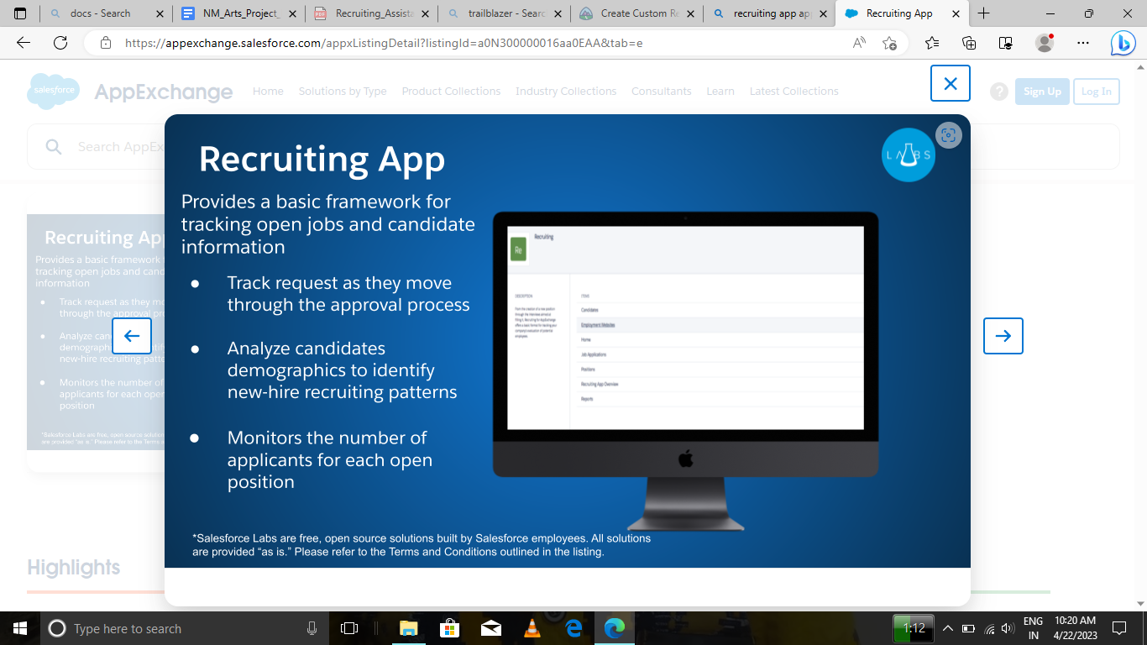

# **CONCLUSION**

FIRST WE CREATED DEVELOPER ACCOUNT THEN WE INSTALLED A UNMANAGED PACKAGE USING APP EXCHANGE . WE CREATED CUSTOM OBJECTS LIKE JOB POSTING SITE, REVIEW, JOB POSTING. WE CREATED TAB FOR JOB POSTING SITE. WE CREATED FIELDS IN JOB POSTING SITES. THEY ARE

JOB POSTING SITE URL : URL

STATUS : PICKLIST

TECHNICAL SITE : CHECKBOX

DESCRIPTION : TEXT AREA

WE MODIFIED PAGE LAYOUT FOR POSITION

CREATED PROFILES AND USERS

CREATED PERMISSION SETS AND ASSIGNED TASKS FOR THEM

WE CREATED CUSTOMISED REPORT

# **FUTURE SCOPE**

## Recruiting will become even more important than it is now

## You'll have to get used to changing your hiring plans

## Recruiters will bring more business strategy

## It’ll be easy to track recruiting activity, but you’ll care more about calculating business impact

## Better tools and tech will be key to boosting your recruiting team's performance

## Better tools and tech will be key to boosting your recruiting team's performance